**DAILY ONLINE ACTIVITIES SUMMARY**

|  |  |  |  |  |  |  |  |  |
| --- | --- | --- | --- | --- | --- | --- | --- | --- |
| **Date:** | **21-05-2020** | | | | | **Name:** | **Shanbhag Atish Manoj** | |
| **Sem & Sec** | **6th - B** | | | | | **USN:** | **4AL17CS085** | |
| **Online Test Summary** | | | | | | | | |
| **Subject** | | **OPERATING SYSTEMS** | | | | | | |
| **Max. Marks** | | **30** | | **Score** | | | **30** | |
| **Certification Course Summary** | | | | | | | | |
| **Course** | **Full stack web development** | | | | | | | |
| **Certificate Provider** | | | **Udemy** | | **Duration** | | | **19.5 hours** |
| **Coding Challenges** | | | | | | | | |
| **Problem Statement: 2 java and 2 C program** | | | | | | | | |
| **Status: executed** | | | | | | | | |
| **Uploaded the report in GitHub** | | | | | **Yes** | | | |
| **If yes Repository name** | | | | | <https://github.com/atish-shanbhag/Updates> | | | |
| **Uploaded the report in slack** | | | | | **Yes** | | | |

Online Test Details: (Attach the snapshot and briefly write the report for the same)

First I A of OPERATING SYSTEM

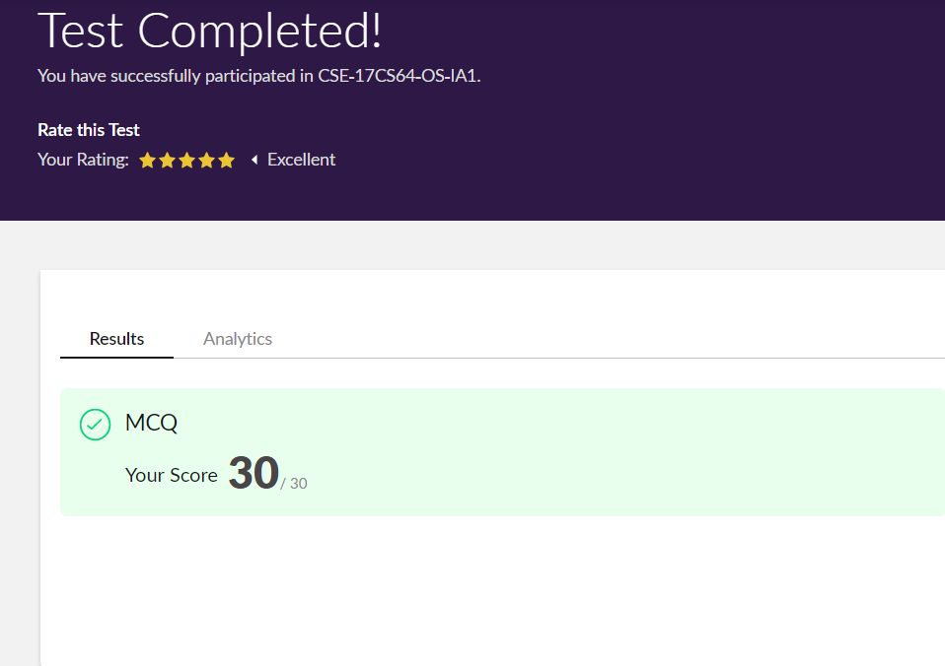

Certification Course Details: (Attach the snapshot and briefly write the report for the same)

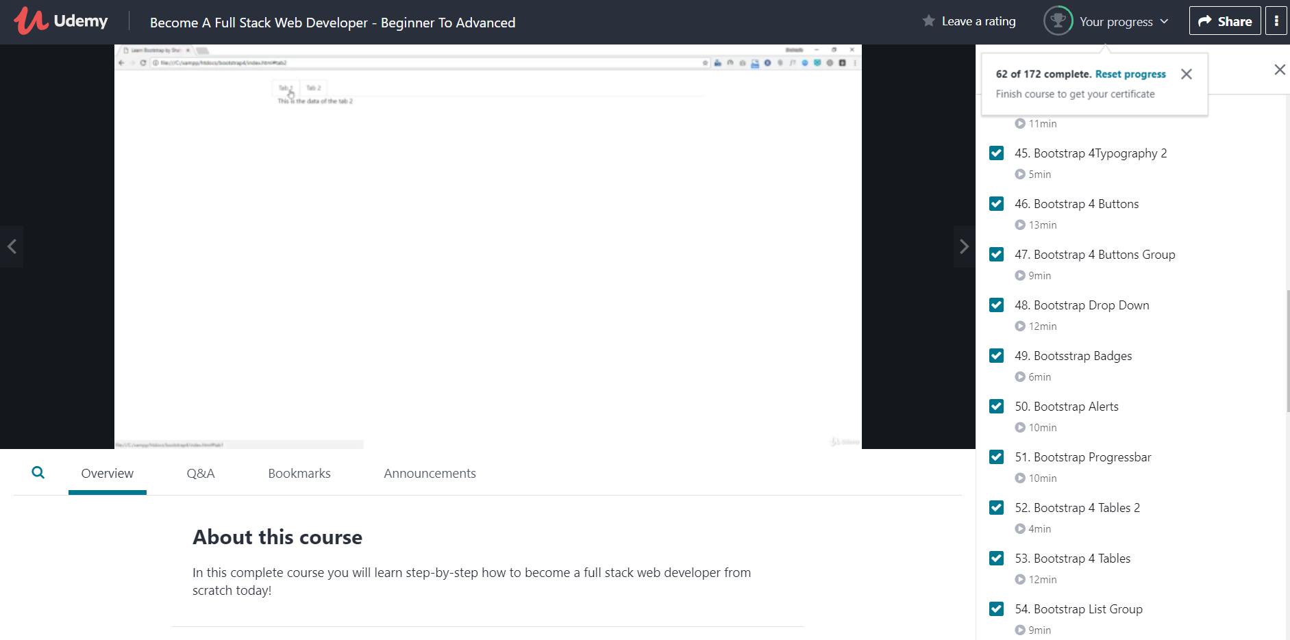

In todays session from 10:00 to 1:00 for online certification I have studied in depth regarding th concepts on bootsstrap and work on it by making options such as making tables, tabs ,buttons and lot more stuffs.

Coding Challenges Details: (Attach the snapshot and briefly write the report for the same)

Problem statements are available in the GitHub account <https://github.com/atish-shanbhag/Updates>

OUTPUT SCREEN-SHOTS

Program 1(Java)

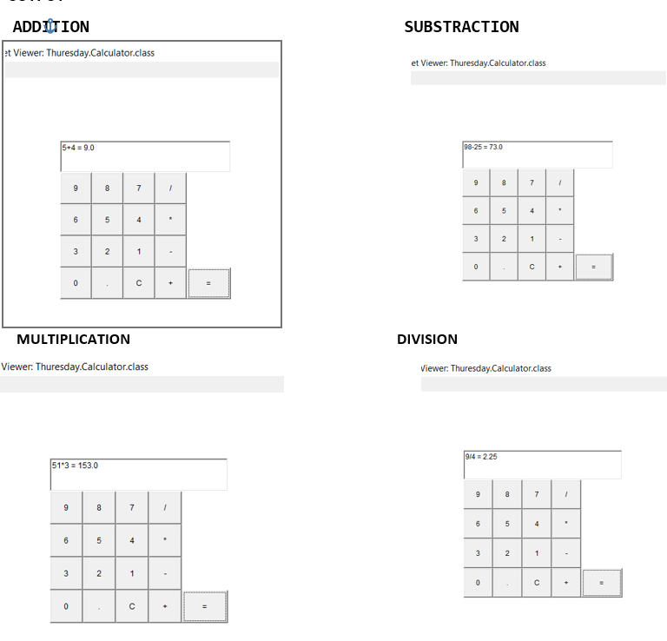

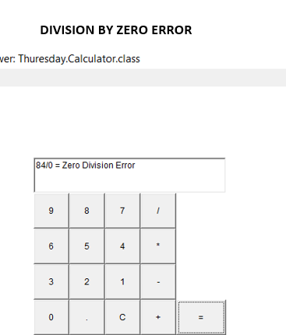

Program 2(C)

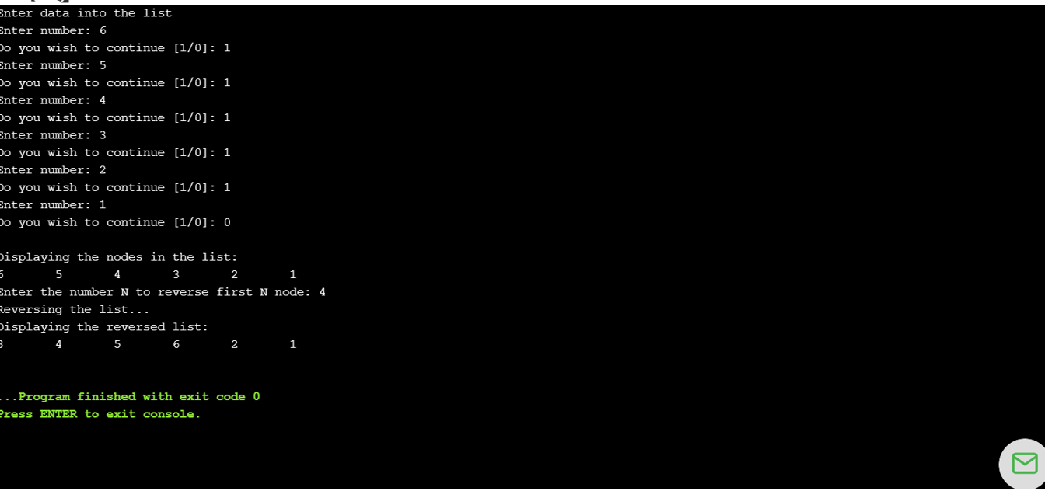

Program 3(C)

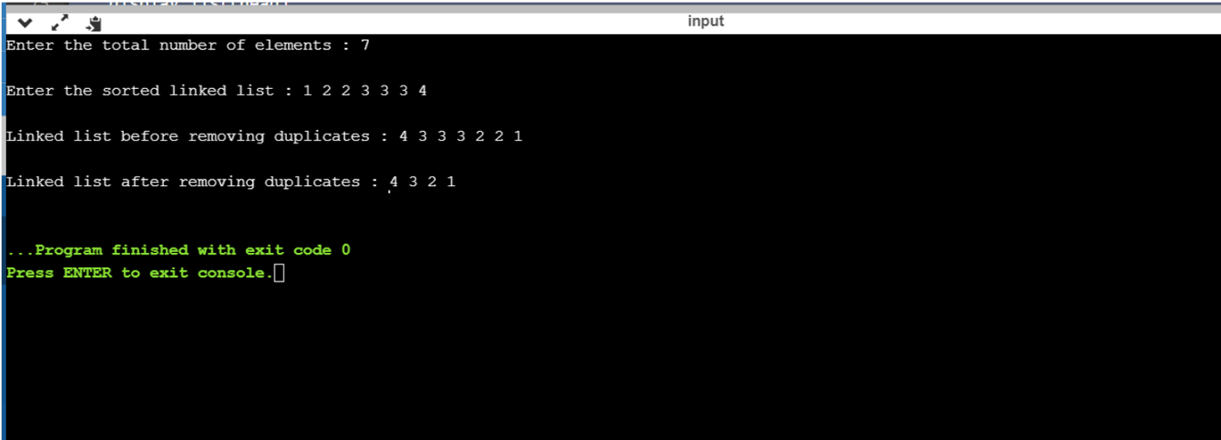

Program 4(Java)

